**Programming Assignment Unit 4**

import java.util.ArrayList;

public class StockAnalyzer {

// Methods for array

public static float calculateAveragePriceArray(float[] prices) {

float sum = 0;

for (float price : prices) {

sum += price;

}

return sum / prices.length;

}

public static float findMaximumPriceArray(float[] prices) {

float max = prices[0];

for (float price : prices) {

if (price > max) {

max = price;

}

}

return max;

}

public static int countOccurrencesArray(float[] prices, float targetPrice) {

int count = 0;

for (float price : prices) {

if (price == targetPrice) {

count++;

}

}

return count;

}

// Methods for ArrayList

public static float calculateAveragePriceArrayList(ArrayList<Float> prices) {

float sum = 0;

for (float price : prices) {

sum += price;

}

return sum / prices.size();

}

public static float findMaximumPriceArrayList(ArrayList<Float> prices) {

float max = prices.get(0);

for (float price : prices) {

if (price > max) {

max = price;

}

}

return max;

}

public static int countOccurrencesArrayList(ArrayList<Float> prices, float targetPrice) {

int count = 0;

for (float price : prices) {

if (price == targetPrice) {

count++;

}

}

return count;

}

public static ArrayList<Float> computeCumulativeSumArrayList(ArrayList<Float> prices) {

ArrayList<Float> cumulativeSum = new ArrayList<>();

float sum = 0;

for (float price : prices) {

sum += price;

cumulativeSum.add(sum);

}

return cumulativeSum;

}

public static void main(String[] args) {

// Test data

float[] stockPricesArray = {10.5f, 12.8f, 11.3f, 14.7f, 13.2f, 15.9f, 14.5f, 16.8f, 17.2f, 18.6f};

ArrayList<Float> stockPricesList = new ArrayList<>();

for (float price : stockPricesArray) {

stockPricesList.add(price);

}

// Test methods for array

System.out.println("Testing methods for array:");

System.out.println("Average Price: " + calculateAveragePriceArray(stockPricesArray));

System.out.println("Maximum Price: " + findMaximumPriceArray(stockPricesArray));

System.out.println("Occurrence Count of 14.5: " + countOccurrencesArray(stockPricesArray, 14.5f));

// Test methods for ArrayList

System.out.println("\nTesting methods for ArrayList:");

System.out.println("Average Price: " + calculateAveragePriceArrayList(stockPricesList));

System.out.println("Maximum Price: " + findMaximumPriceArrayList(stockPricesList));

System.out.println("Occurrence Count of 14.5: " + countOccurrencesArrayList(stockPricesList, 14.5f));

System.out.println("Cumulative Sum: " + computeCumulativeSumArrayList(stockPricesList));

}

}

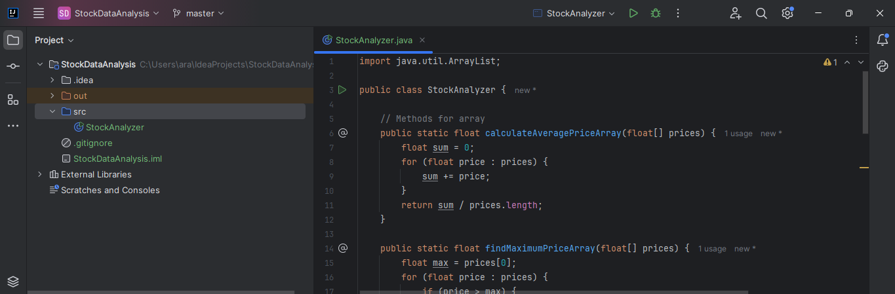

Figure 1 Code Sample

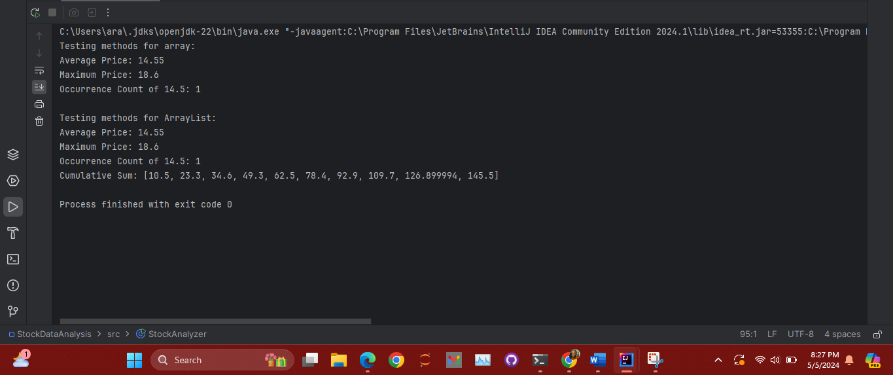

Figure 2 Code Output

The code is a Java program that analyzes stock prices. It contains a class `StockAnalyzer` with several methods to perform different operations on stock prices. These operations include calculating the average price, finding the maximum price, counting the occurrences of a specific price, and computing the cumulative sum of prices. Each operation is implemented as a separate method, which makes your code modular and easy to understand.

The methods are implemented for both arrays and ArrayLists, which makes your code versatile and able to handle different data structures. In the `main` method, you create test data and call each method to demonstrate its functionality. The results are printed to the console. This demonstrates good testing practices and helps verify that your methods are working correctly. The variable names you've chosen are descriptive, which makes your code easy to read and understand. Overall, your code follows good coding practices and is well-structured and efficient.